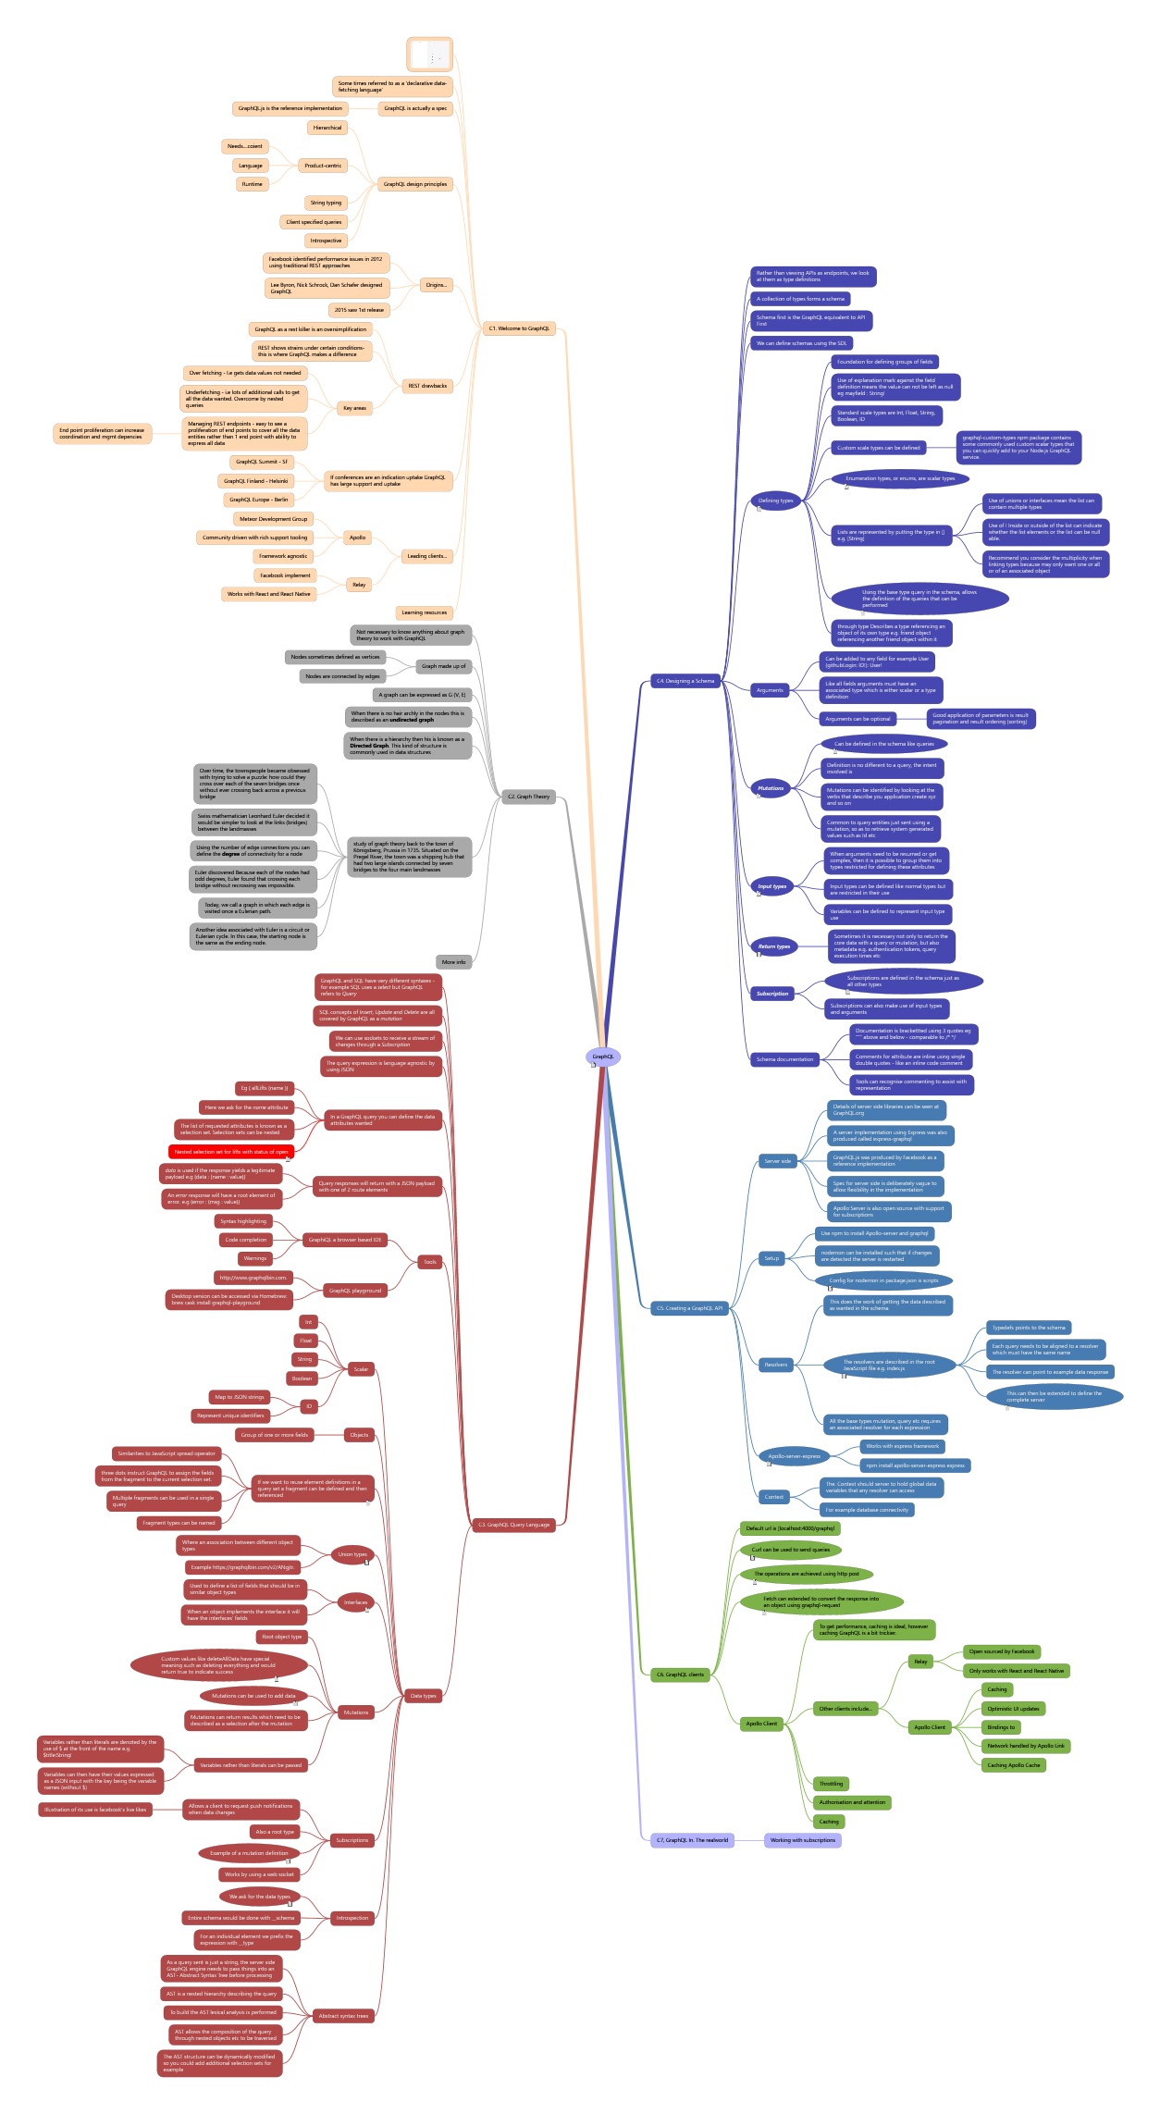

GraphQL
Drawn from Learning GraphQL From O Reilly by Eve Porcello and Alex Banks

- C4. Designing a Schema
  - Rather than viewing APIs as endpoints, we look at them as type definitions
  - A collection of types forms a schema
  - Schema first is the GraphQL equivalent to API First
  - We can define schemas using the SDL
  - Defining types
type Photo {
id: ID!
name: String!
url: String!
description: String
}
    - Foundation for defining groups of fields
    - Use of explanation mark against the field definition means the value can not be left as null eg mayfield : String!
    - Standard scale types are Int, Float, String, Boolean, ID
    - Custom scale types can be defined
      - graphql-custom-types npm package contains some commonly used custom scalar types that you can quickly add to your Node.js GraphQL service.
    - Enumeration types, or enums, are scalar types
enum PhotoCategory {
SELFIE
PORTRAIT
ACTION
LANDSCAPE
GRAPHIC
}
    - Lists are represented by putting the type in [] e.g. [String]
      - Use of unions or interfaces mean the list can contain multiple types
      - Use of ! Inside or outside of the list can indicate whether the list elements or the list can be null able.
      - Recommend you consider the multiplicity when linking types because may only want one or all or of an associated object
    - Using the base type query in the schema, allows the definition of the queries that can be performed
type Query {
totalPhotos: Int!
allPhotos: [Photo!]!
totalUsers: Int!
allUsers: [User!]!
}
schema {
query: Query
}
    - through type Describes a type referencing an object of its own type e.g. friend object referencing another friend object within it
  - Arguments
    - Can be added to any field for example User(githubLogin: ID!): User!
    - Like all fields arguments must have an associated type which is either scalar or a type definition
    - Arguments can be optional
      - Good application of parameters is result pagination and result ordering (sorting)
  - Mutations
schema {
query: Query
mutation: Mutation
}
    - Can be defined in the schema like queries
type Mutation {
postPhoto(
name: String!
description: String
category: PhotoCategory=PORTRAIT
): Photo! }
    - Definition is no different to a query, the intent involved is
    - Mutations can be identified by looking at the verbs that describe you application create xyz and so on
    - Common to query entities just sent using a mutation, so as to retrieve system generated values such as Id etc
  - Input types
input PostPhotoInput {
name: String!
description: String
category: PhotoCategory=PORTRAIT
}
type Mutation {
postPhoto(input: PostPhotoInput!): Photo!
}
    - When arguments need to be resumed or get complex, then it is possible to group them into types restricted for defining these attributes
    - Input types can be defined like normal types but are restricted in their use
    - Variables can be defined to represent input type use
  - Return types
type AuthPayload {
user: User!
token: String!
}
type Mutation { ...
githubAuth(code: String!): AuthPayload!
}
    - Sometimes it is necessary not only to return the core data with a query or mutation, but also metadata e.g. authentication tokens, query execution times etc
  - Subscription
    - Subscriptions are defined in the schema just as all other types
type Subscription {
newPhoto: Photo!
newUser: User!
}
schema {
query: Query
mutation: Mutation
subscription: Subscription
}
    - Subscriptions can also make use of input types and arguments
  - Schema documentation
    - Documentation is brackettted using 3 quotes eg “”” above and below - comparable to /* */
    - Comments for attribute are inline using single double quotes - like an inline code comment
    - Tools can recognise commenting to assist with representation
- C5. Creating a GraphQL API
  - Server side
    - Details of server side libraries can be seen at GraphQL.org
    - A server implementation using Express was also produced called express-graphql
    - GraphQL.js was produced by Facebook as a reference implementation
    - Spec for server side is deliberately vague to allow flexibility in the implementation
    - Apollo Server is also open source with support for subscriptions
  - Setup
    - Use npm to install Apollo-server and graphql
    - nodemon can be installed such that if changes are detected the server is restarted
    - Config for nodemon in package.json is scripts
“scripts”: {
“start”: “nodemon -e js,json,graphql”
}
  - Resolvers
    - This does the work of getting the data described as wanted in the schema
    - The resolvers are described in the root JavaScript file e.g. index.js
const typeDefs = type Query {
totalPhotos: Int!
}
const resolvers = { Query: {
totalPhotos: () => 42 }
}
      - Typedefs points to the schema
      - Each query needs to be aligned to a resolver which must have the same name
      - The resolver can point to example data response
      - This can then be extended to define the complete server
// 1. Require ‘apollo-server’
const { ApolloServer } = require(‘apollo-server’)
const typeDefs = type Query { totalPhotos: Int! }
const resolvers = { Query: {
totalPhotos: () => 42 }
}
// 2. Create a new instance of the server.
// 3. Send it an object with typeDefs (the schema) and resolvers const server = new ApolloServer({
typeDefs,
resolvers
})
// 4. Call listen on the server to launch the web server
server .listen()
.then(({url}) => console.log(GraphQL Service running on ${url}))
    - All the base types mutation, query etc requires an associated resolver for each expression
  - Apollo-server-express
// 1. Require apollo-server-express and express
const { ApolloServer } = require(‘apollo-server-express’) const express = require(‘express’)
...
// 2. Call express() to create an Express application
var app = express()
const server = new ApolloServer({ typeDefs, resolvers })
// 3. Call applyMiddleware() to allow middleware mounted on the same path
server.applyMiddleware({ app })
// 4. Create a home route
app.get(‘/‘, (req, res) => res.end(‘Welcome to the PhotoShare API’))
// 5. Listen on a specific port
app.listen({ port: 4000 }, () => console.log(GraphQL Server running @ http://localhost:4000${server.graphqlPath}) )
    - Works with express framework
    - npm install apollo-server-express express
  - Context
    - The. Context should server to hold global data variables that any resolver can access
    - For example database connectivity
- C6. GraphQL clients
  - Default url is [localhost:4000/graphql
  - Curl can be used to send queries
curl -X POST
-H “Content-Type: application/json”
—data ‘{ “query”: “{totalUsers, totalPhotos}” }’ \ http://localhost:4000/graphql
  - The operations are achieved using http post
var query = {totalPhotos, totalUsers} var url = ‘http://localhost:4000/graphql’
var opts = {
method: ‘POST’,
headers: { ‘Content-Type’: ‘application/json’ }, body: JSON.stringify({ query })
}
fetch(url, opts)
.then(res => res.json()) .then(console.log) .catch(console.error)
  - Fetch can extended to convert the response into an object using graphql-request
import { request } from ‘graphql-request’
var query = query listUsers { allUsers { name avatar } }
request(‘http://localhost:4000/graphql’, query) .then(console.log)
.catch(console.error)
  - Apollo Client
    - To get performance, caching is ideal, however caching GraphQL is a bit trickier.
    - Other clients include...
      - Relay
        - Open sourced by Facebook
        - Only works with React and React Native
      - Apollo Client
        - Caching
        - Optimistic UI updates
        - Bindings to
        - Network handled by Apollo Link
        - Caching Apollo Cache
    - Throttling
    - Authorisation and attention
    - Caching
- C7, GraphQL In. The realworld
  - Working with subscriptions
- C3. GraphQL Query Language
  - GraphQL and SQL have very different syntaxes - for example SQL uses a select but GraphQL refers to Query
  - SQL concepts of Insert, Update and Delete are all covered by GraphQL as a mutation
  - We can use sockets to receive a stream of changes through a Subscription
  - The query expression is language agnostic by using JSON
  - In a GraphQL query you can define the data attributes wanted
    - Eg { allLifts {name }}
    - Here we ask for the name attribute
    - The list of requested attributes is known as a selection set. Selection sets can be nested
    - Nested selection set for lifts with status of open
query liftsAndTrails {
open: liftCount(status: OPEN)
chairlifts: allLifts {
liftName: name
status }
skiSlopes: allTrails {
name
difficulty }
}
  - Query responses will return with a JSON payload with one of 2 route elements
    - data is used if the response yields a legitimate payload e.g {data : {name : value}}
    - An error response will have a root element of error. e.g {error : {msg : value}}
  - Tools
    - GraphiQL a browser based IDE
      - Syntax highlighting
      - Code completion
      - Warnings
    - GraphQL playgrround
      - http://www.graphqlbin.com.
      - Desktop version can be accessed via Homebrew:
brew cask install graphql-playground
  - Data types
    - Scalar
      - Int
      - Float
      - String
      - Boolean
      - ID
        - Map to JSON strings
        - Represent unique identifiers
    - Objects
      - Group of one or more fields
    - If we want to reuse element definitions in a query set a fragment can be defined and then referenced
fragment liftInfo on Lift {
name
status
capacity
night
elevationGain
}
query {
Lift(id: “jazz-cat”) {
...liftInfo trailAccess {
name
difficulty }
}
Trail(id: “river-run”) { name
difficulty
accessedByLifts {
...liftInfo }
} }
      - Similarities to JavaScript spread operator
      - three dots instruct GraphQL to assign the fields from the fragment to the current selection set.
      - Multiple fragments can be used in a single query
      - Fragment types can be named
    - Union types
query schedule {
agenda {
...on Workout { name
reps
}
...on StudyGroup {
name
subject
students
} }
}
      - Where an association between different object types
      - Example https://graphqlbin.com/v2/ANgjtr.
    - Interfaces
query schedule {
agenda {
name
start
end
...on Workout {
reps }
} }
The schedule query has been modified to additionally request the reps when the ScheduleItem is a Workout.
      - Used to define a list of fields that should be in similar object types
      - When an object implements the interface it will have the interfaces’ fields
    - Mutations
      - Root object type
      - Custom values like deleteAllData have special meaning such as deleting everything and would return true to indicate success
mutation burnItDown {
deleteAllData
}
      - Mutations can be used to add data
mutation createSong {
addSong(title:”No Scrubs”, numberOne: true,
performerName:”TLC”) {
id
title
numberOne
} }
Yields a result of
{
“data”: { “addSong”: {
“id”: “5aca534f4bb1de07cb6d73ae”, “title”: “No Scrubs”, “numberOne”: true
} }
      - Mutations can return results which need to be described as a selection after the mutation
      - Variables rather than literals can be passed
        - Variables rather than literals are denoted by the use of $ at the front of the name e.g. $title:String!
        - Variables can then have their values expressed as a JSON input with the key being the variable names (without $)
    - Subscriptions
      - Allows a client to request push notifications when data changes
        - Illustration of its use is facebook’s live likes
      - Also a root type
      - Example of a mutation definition
subscription {
liftStatusChange {
name
capacity
status
}}
      - Works by using a web socket
    - Introspection
      - We ask for the data types
query {
__schema {
types { name
description
}
} }
      - Entire schema would be done with __schema
      - For an individual element we prefix the expression with __type
    - Abstract syntax trees
      - As a query sent is just a string, the server side GraphQL engine needs to pass things into an AST- Abstract Syntax Tree before processing
      - AST is a nested hierarchy describing the query
      - To build the AST lexical analysis is performed
      - AST allows the composition of the query through nested objects etc to be traversed
      - The AST structure can be dynamically modified so you could add additional selection sets for example
- C2. Graph Theory
  - Not necessary to know anything about graph theory to work with GraphQL
  - Graph made up of
    - Nodes sometimes defined as vertices
    - Nodes are connected by edges
  - A graph can be expressed as G (V, E)
  - When there is no hair archly in the nodes this is described as an undirected graph
  - When there is a hierarchy then his is known as a Directed Graph. This kind of structure is commonly used in data structures
  - study of graph theory back to the town of Königsberg, Prussia in 1735. Situated on the Pregel River, the town was a shipping hub that had two large islands connected by seven bridges to the four main landmasses
    - Over time, the townspeople became obsessed with trying to solve a puzzle: how could they cross over each of the seven bridges once without ever crossing back across a previous bridge
    - Swiss mathematician Leonhard Euler decided it would be simpler to look at the links (bridges) between the landmasses
    - Using the number of edge connections you can define the degree of connectivity for a node
    - Euler discovered Because each of the nodes had odd degrees, Euler found that crossing each bridge without recrossing was impossible.
    - Today, we call a graph in which each edge is visited once a Eulerian path.
    - Another idea associated with Euler is a circuit or Eulerian cycle. In this case, the starting node is the same as the ending node.
  - More info
- C1. Welcome to GraphQL

  - Some times referred to as a ‘declarative data-fetching language’
  - GraphQL is actually a spec
    - GraphQL.js is the reference implementation
  - GraphQL design principles
    - Hierarchical
    - Product-centric
      - Needs....coient
      - Language
      - Runtime
    - String typing
    - Client specified queries
    - Introspective
  - Origins...
    - Facebook identified performance issues in 2012 using traditional REST approaches
    - Lee Byron, Nick Schrock, Dan Schafer designed GraphQL
    - 2015 saw 1st release
  - REST drawbacks
    - GraphQL as a rest killer is an oversimplification
    - REST shows strains under certain conditions- this is where GraphQL makes a difference
    - Key areas
      - Over fetching - I.e gets data values not needed
      - Underfetching - i.e lots of additional calls to get all the data wanted. Overcome by nested queries
      - Managing REST endpoints - easy to see a proliferation of end points to cover all the data entities rather than 1 end point with ability to express all data
        - End point proliferation can increase coordination and mgmt depencies
  - If conferences are an indication uptake GraphQL has large support and uptake
    - GraphQL Summit - SF
    - GraphQL Finland - Helsinki
    - GraphQL Europe - Berlin
  - Leading clients...
    - Apollo
      - Meteor Development Group
      - Community driven with rich support tooling
      - Framework agnostic
    - Relay
      - Facebook implement
      - Works with React and React Native
  - Learning resources

