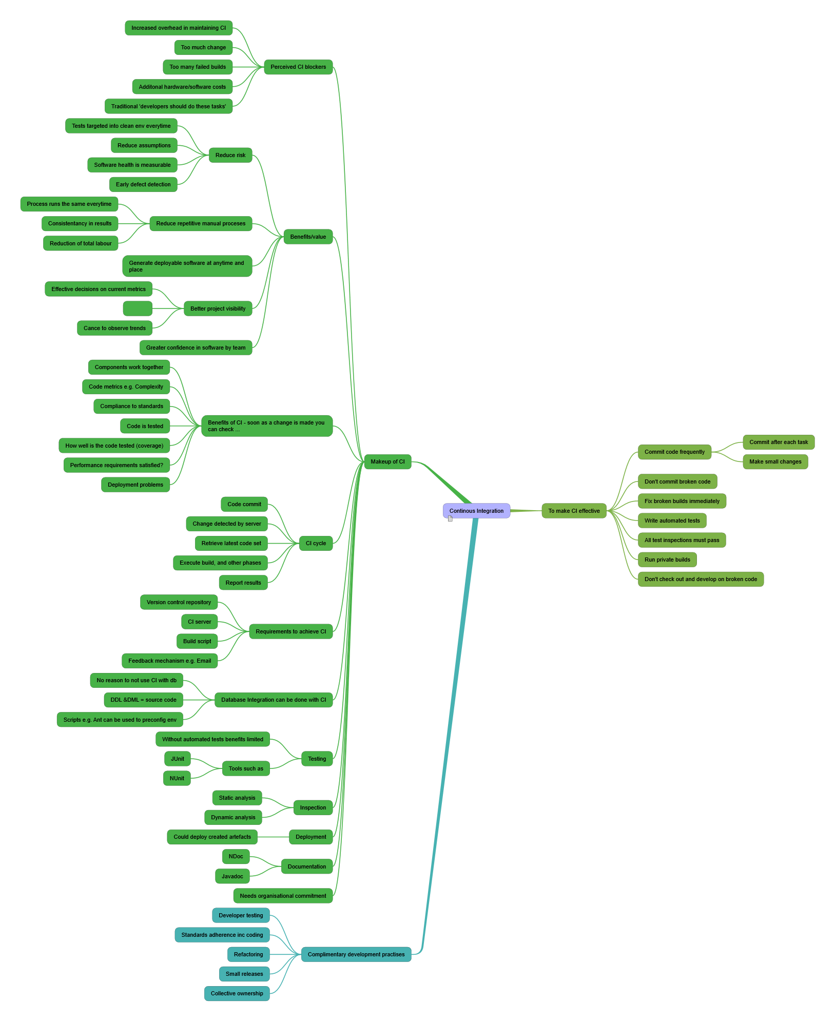

Continous Integration
Based upon the book Continuous Integration by Paul Duvall
- To make CI effective
  - Commit code frequently
    - Commit after each task
    - Make small changes
  - Don't commit broken code
  - Fix broken builds immediately
  - Write automated tests
  - All test inspections must pass
  - Run private builds
  - Don't check out and develop on broken code
- Complimentary development practises
  - Developer testing
  - Standards adherence inc coding
  - Refactoring
  - Small releases
  - Collective ownership
- Makeup of CI
  - Perceived CI blockers
    - Increased overhead in maintaining CI
    - Too much change
    - Too many failed builds
    - Additonal hardware/software costs
    - Traditional 'developers should do these tasks'
  - Benefits/value
    - Reduce risk
      - Tests targeted into clean env everytime
      - Reduce assumptions
      - Software health is measurable
      - Early defect detection
    - Reduce repetitive manual proceses
      - Process runs the same everytime
      - Consistentancy in results
      - Reduction of total labour
    - Generate deployable software at anytime and place
    - Better project visibility
      - Effective decisions on current metrics

      - Cance to observe trends
    - Greater confidence in software by team
  - Benefits of CI - soon as a change is made you can check ...
    - Components work together
    - Code metrics e.g. Complexity
    - Compliance to standards
    - Code is tested
    - How well is the code tested (coverage)
    - Performance requirements satisfied?
    - Deployment problems
  - CI cycle
    - Code commit
    - Change detected by server
    - Retrieve latest code set
    - Execute build, and other phases
    - Report results
  - Requirements to achieve CI
    - Version control repository
    - CI server
    - Build script
    - Feedback mechanism e.g. Email
  - Database Integration can be done with CI
    - No reason to not use CI with db
    - DDL &DML = source code
    - Scripts e.g. Ant can be used to preconfig env
  - Testing
    - Without automated tests benefits limited
    - Tools such as
      - JUnit
      - NUnit
  - Inspection
    - Static analysis
    - Dynamic analysis
  - Deployment
    - Could deploy created artefacts
  - Documentation
    - NDoc
    - Javadoc
  - Needs organisational commitment

