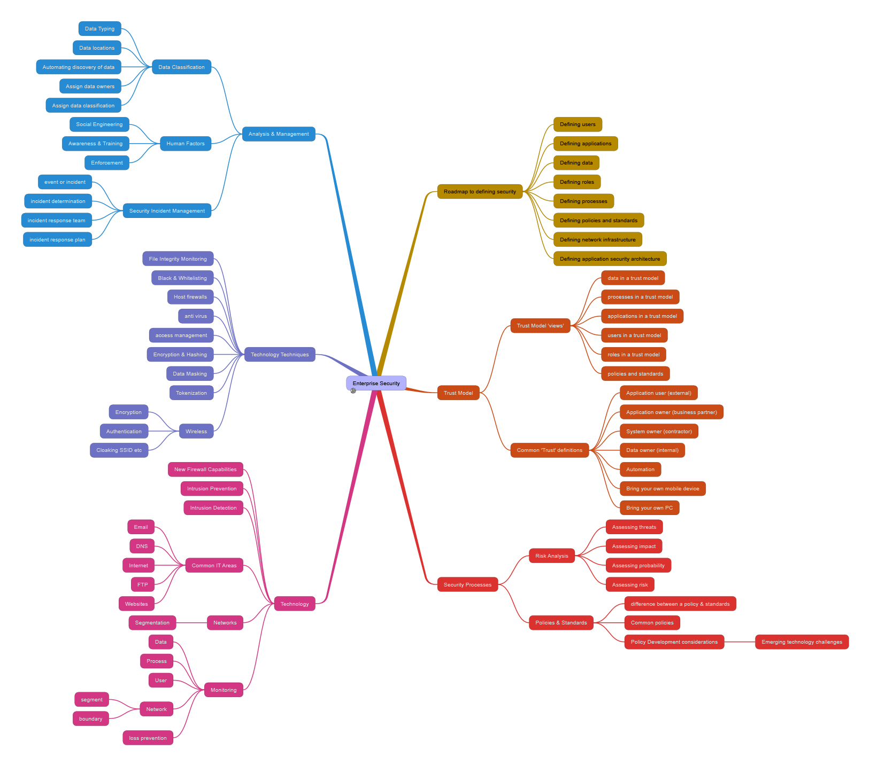

Enterprise Security
http://www.packtpub.com/enterprise-security-for-securing-data/book
- Roadmap to defining security
  - Defining users
  - Defining applications
  - Defining data
  - Defining roles
  - Defining processes
  - Defining policies and standards
  - Defining network infrastructure
  - Defining application security architecture
- Trust Model
  - Trust Model 'views'
    - data in a trust model
    - processes in a trust model
    - applications in a trust model
    - users in a trust model
    - roles in a trust model
    - policies and standards
  - Common 'Trust' definitions
    - Application user (external)
    - Application owner (business partner)
    - System owner (contractor)
    - Data owner (internal)
    - Automation
    - Bring your own mobile device
    - Bring your own PC
- Security Processes
  - Risk Analysis
    - Assessing threats
    - Assessing impact
    - Assessing probability
    - Assessing risk
  - Policies & Standards
    - difference between a policy & standards
    - Common policies
    - Policy Development considerations
      - Emerging technology challenges
- Technology
  - New Firewall Capabilities
  - Intrusion Prevention
  - Intrusion Detection
  - Common IT Areas
    - Email
    - DNS
    - Internet
    - FTP
    - Websites
  - Networks
    - Segmentation
  - Monitoring
    - Data
    - Process
    - User
    - Network
      - segment
      - boundary
    - loss prevention
- Technology Techniques
  - File Integrity Monitoring
  - Black & Whitelisting
  - Host firewalls
  - anti virus
  - access management
  - Encryption & Hashing
  - Data Masking
  - Tokenization
  - Wireless
    - Encryption
    - Authentication
    - Cloaking SSID etc
- Analysis & Management
  - Data Classification
    - Data Typing
    - Data locations
    - Automating discovery of data
    - Assign data owners
    - Assign data classification
  - Human Factors
    - Social Engineering
    - Awareness & Training
    - Enforcement
  - Security Incident Management
    - event or incident
    - incident determination
    - incident response team
    - incident response plan

