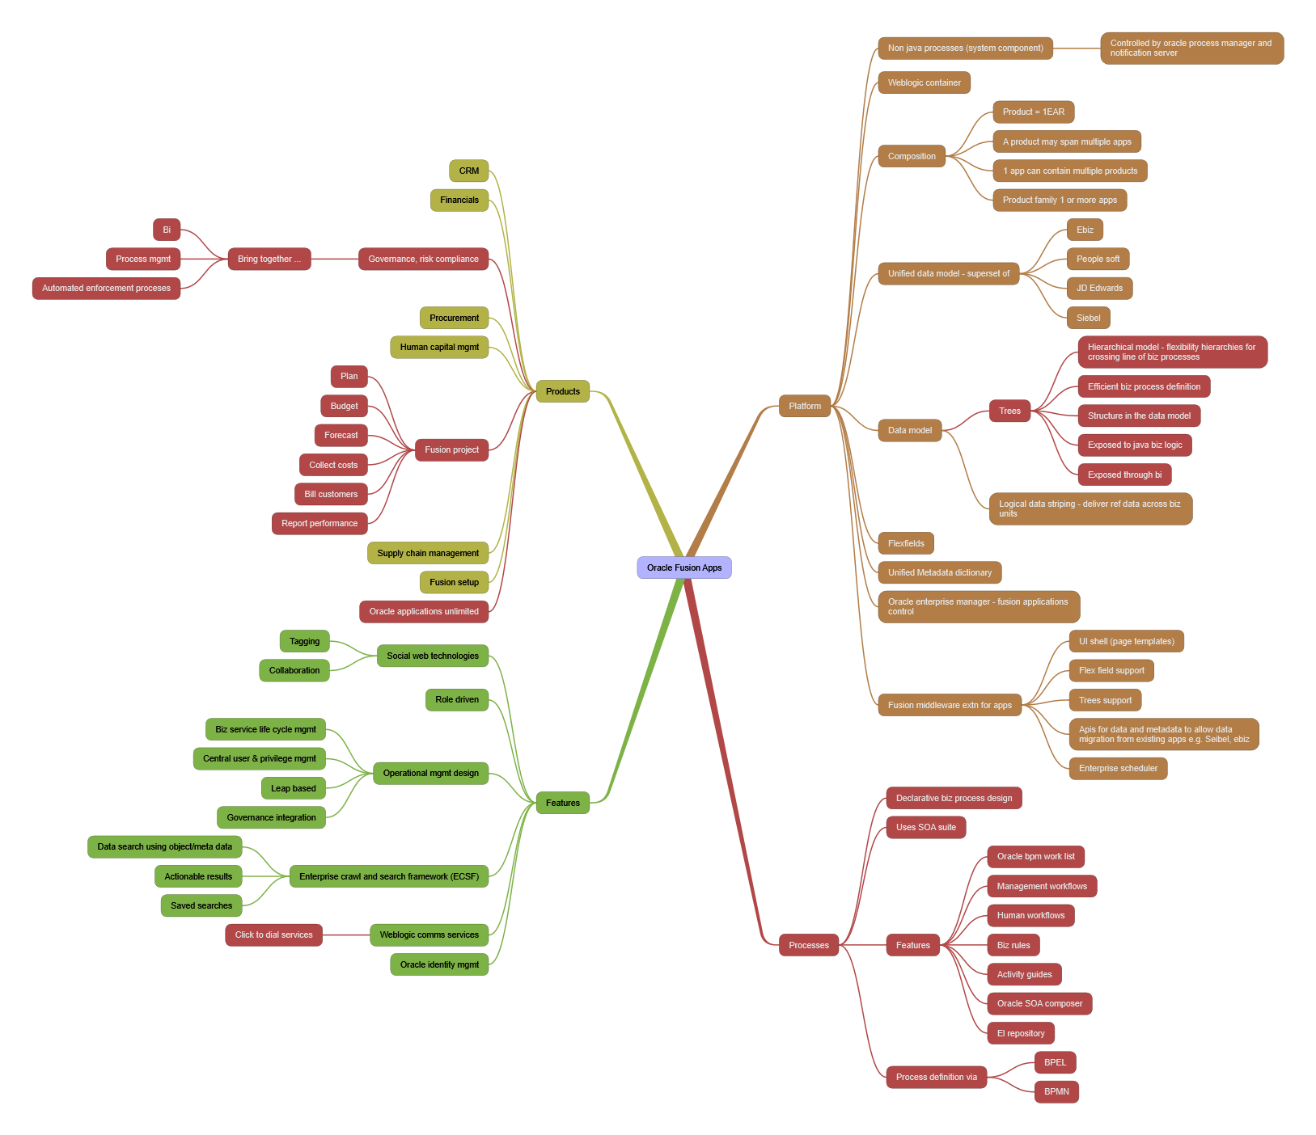

Oracle Fusion Apps

- Platform
  - Non java processes (system component)
    - Controlled by oracle process manager and notification server
  - Weblogic container
  - Composition
    - Product = 1EAR
    - A product may span multiple apps
    - 1 app can contain multiple products
    - Product family 1 or more apps
  - Unified data model - superset of
    - Ebiz
    - People soft
    - JD Edwards
    - Siebel
  - Data model
    - Trees
      - Hierarchical model - flexibility hierarchies for crossing line of biz processes
      - Efficient biz process definition
      - Structure in the data model
      - Exposed to java biz logic
      - Exposed through bi
    - Logical data striping - deliver ref data across biz units
  - Flexfields
  - Unified Metadata dictionary
  - Oracle enterprise manager - fusion applications control
  - Fusion middleware extn for apps
    - UI shell (page templates)
    - Flex field support
    - Trees support
    - Apis for data and metadata to allow data migration from existing apps e.g. Seibel, ebiz
    - Enterprise scheduler
- Processes
  - Declarative biz process design
  - Uses SOA suite
  - Features
    - Oracle bpm work list
    - Management workflows
    - Human workflows
    - Biz rules
    - Activity guides
    - Oracle SOA composer
    - El repository
  - Process definition via
    - BPEL
    - BPMN
- Features
  - Social web technologies
    - Tagging
    - Collaboration
  - Role driven
  - Operational mgmt design
    - Biz service life cycle mgmt
    - Central user & privilege mgmt
    - Leap based
    - Governance integration
  - Enterprise crawl and search framework (ECSF)
    - Data search using object/meta data
    - Actionable results
    - Saved searches
  - Weblogic comms services
    - Click to dial services
  - Oracle identity mgmt
- Products
  - CRM
  - Financials
  - Governance, risk compliance
    - Bring together ...
      - Bi
      - Process mgmt
      - Automated enforcement proceses
  - Procurement
  - Human capital mgmt
  - Fusion project
    - Plan
    - Budget
    - Forecast
    - Collect costs
    - Bill customers
    - Report performance
  - Supply chain management
  - Fusion setup
  - Oracle applications unlimited

