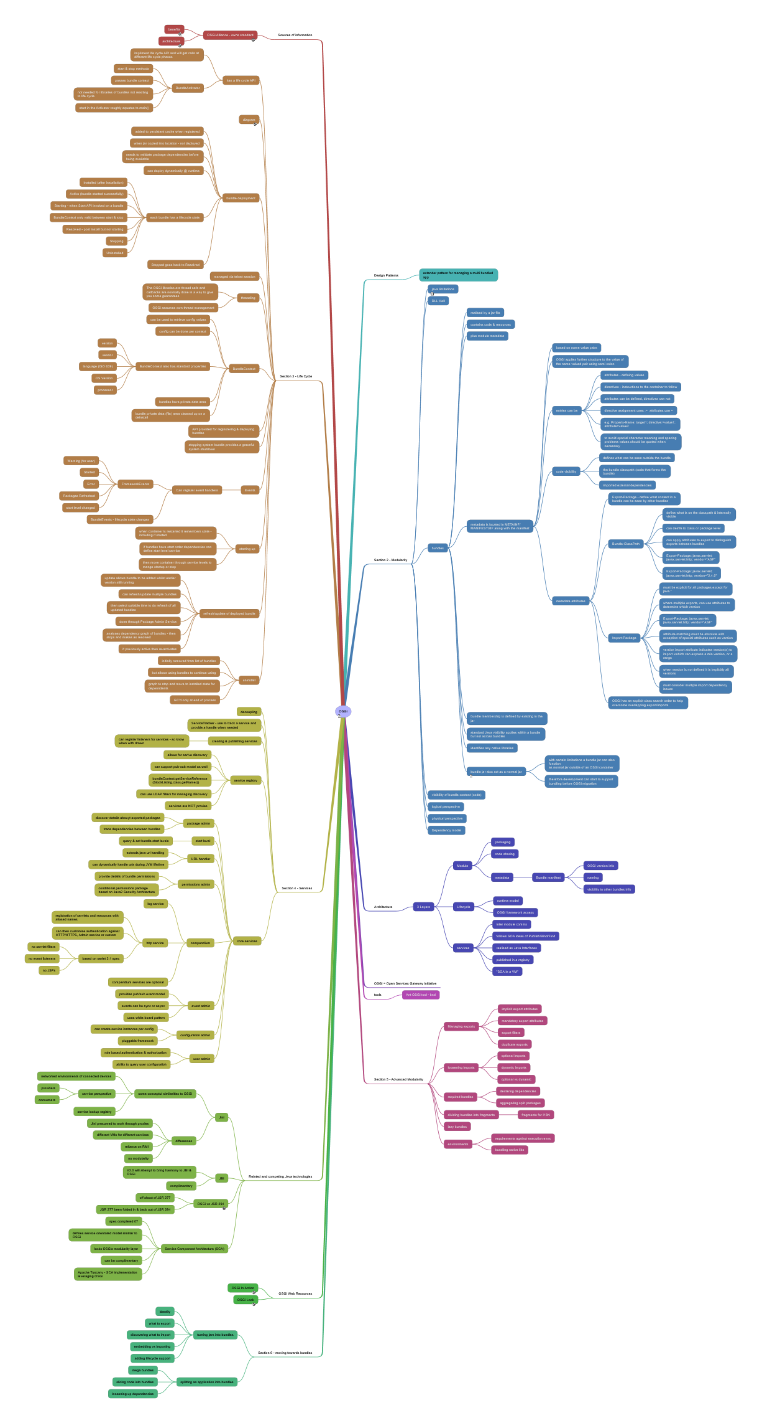

OSGi
This mind map is primarily driven during thereading of Manning's OSGi In Action, but contains a lot of additional information drawn from other sources
- Design Patterns
  - extender pattern for managing a multi bundled app
- Section 2 - Modularity
  - java limitations
Native java modularity is looking at code functionality and modularisation. Can be described as "programming in the small" rather than considering modularity at the product / solution / enterprise level
  - DLL Hell
  - bundles
    - realised by a jar file
    - contains code & resources
    - plus module metadata
    - metadata is located in METAINF/ MANIFEST.MF along with the manifest
      - based on name value pairs
      - OSGi applies further structure to the value of the name valued pair using semi colon
      - entries can be
        - attributes - defining values
        - directives - instructions to the container to follow
        - attributes can be defined, directives can not
        - directive assignment uses := attributes use =
        - e.g. Property-Name: target1; directive:=value1; attribute=value2
        - to avoid spacial character meaning and spacing problems values should be quoted when necessary
      - code visibility
        - defines what can be seen outside the bundle
        - the bundle classpath (code that forms the bundle)
        - imported external dependencies
      - metadata attributes
        - Export-Package - define what content in a bundle can be seen by other bundles
        - Bundle-ClassPath
          - define what is on the classpath & internally visible
          - can deinfe to class or package level
          - can apply attributes to export to distinguish exports between bundles
          - Export-Package: javax.servlet; javax.servlet.http; vendor="ASF"
          - Export-Package: javax.servlet; javax.servlet.http; version="2.4.0"
        - Import-Package
          - must be explicit for all packages except for java.*
          - where multiple exports, can use attributes to determine which version
          - Export-Package: javax.servlet; javax.servlet.http; vendor="ASF"
          - attribute matching must be absolute with exception of special attributes such as version
          - version import attribute indicates version(s) to import vwhich can express a min version, or a range
          - when version is not defined it is implicitly all versions
          - must consider multiple import dependency issues
        - OSGi has an explicit class search order to help overcome overlapping export/imports
    - bundle membership is defined by existing in the jar
    - standard Java visibility applies within a bundle but not across bundles
    - identifies any native libraries
    - bundle jar also act as a normal jar
See section 2,4,5 of OSGi in action for more details
      - with certain limitations a bundle jar can also function
as normal jar outside of an OSGi container
      - therefore development can start to support bundling before OSGi migration
  - visibility of bundle content (code)
  - logical perspective
  - physical perspective
  - Dependency model
- Architecture
  - 3 Layers
    - Module
      - packaging
      - code sharing
      - metadata
        - Bundle manifest
          - OSGi version info
          - naming
          - visibility to other bundles info
    - Lifecycle
      - runtime model
      - OSGi framework access
    - services
      - inter module comms
      - follows SOA ideas of Publish/Bind/Find
      - realised as Java Interfaces
      - published in a registry
      - "SOA in a VM"
- OSGi = Open Services Gateway initiative
- tools
  - Ant OSGi tool - bnd
- Section 5 - Advanced Modularity
  - Managing exports
    - implicit export attributes
    - mandatory export attributes
    - export filters
    - duplicate exports
  - loosening imports
    - optional imports
    - dynamic imports
    - optional vs dynamic
  - required bundles
    - declaring dependencies
    - aggregating split packages
  - dividing bundles into fragments
    - fragments for I18N
  - lazy bundles
  - environments
    - requirements against execution envs
    - bundling native libs
- Section 6 - moving towards bundles
  - turning jars into bundles
    - identity
    - what to export
    - discovering what to import
    - embedding vs importing
    - adding lifecycle support
  - splitting an application into bundles
    - mega bundles
    - slicing code into bundles
    - loosening up dependencies
- OSGi Web Resources
  - OSGi In Action
http://www.manning.com/hall/
  - OSGi Look
http://www.osgilook.com/
- Related and competing Java technologies
  - Jini
    - some conceptul similarities to OSGi
      - networked environments of connected devices
      - service perspective
        - providers
        - consumers
      - service lookup registry
    - differences
      - Jini presumed to work through proxies
      - different VMs for different services
      - reliance on RMI
      - no modularity
  - JBI
    - V2.0 will attempt to bring harmony to JBI & OSGi
    - complimentary
  - OSGi vs JSR 294
http://www.osgi.org/blog/2008/04/jsr-294-superpackages-no-more.html
    - off shoot of JSR 277
    - JSR 277 been folded in & back out of JSR 294
  - Service Component Architecture (SCA)
    - spec completed 07
    - defines service orientated model similiar to OSGi
    - lacks OSGis modularity layer
    - can be complimentary
    - Apache Tuscany - SCA implementation leveraging OSGi
- Section 4 - Services
  - decoupling
  - ServiceTracker - use to track a service and provide a handle when needed
  - creating & publishing services
    - can register listeners for services - so know when with drawn
  - service registry
    - allows for serive discovery
    - can support pub-sub model as well
    - bundleContext.getServiceReference(StockListing.class.getName())
    - can use LDAP filters for managing discovery
    - services are NOT proxies
  - core services
    - package admin
      - discover details abouyt exported packages
      - trace dependencies between bundles
    - start level
      - query & set bundle start levels
    - URL handler
      - extends java url handling
      - can dynamically handle urls during JVM lifetime
    - permissions admin
      - provide details of bundle permissions
      - conditional permissions package
based on Java2 Security Architecture
    - compendium
      - log service
      - http service
        - registration of servlets and resources with aliased names
        - can then customise authentication against
HTTP/HTTPS, Admin service or custom
        - based on serlet 2.1 spec
          - no servlet filters
          - no event listeners
          - no JSPs
      - compendium services are optional
    - event admin
      - provides pub/sub event model
      - events can be sync or async
      - uses white board pattern
    - configuration admin
      - can create service instances per config
      - pluggable framework
    - user admin
      - role based authentication & authorization
      - ability to query user configuratioh
- Section 3 - Life Cycle
  - has a life cycle API
    - impliment life cycle API and will get calls at different life cycle phases
    - BundleActivator
      - start & stop methods
      - passes bundle context
      - not needed for libraries of bundles not reacting to life cycle
      - start in the Activator roughly equates to main()
  - diagram
http://upload.wikimedia.org/wikipedia/en/thumb/c/cc/OSGi_Bundle_Life-Cycle.svg/250px-OSGi_Bundle_Life-Cycle.svg.png
  - bundle deployment
    - added to persistent cache when registered
    - when jar copied into location - not deployed
    - needs to validate package dependencies before being available
    - can deploy dynamically @ runtime
    - each bundle has a lifecycle state
      - Installed (after installation)
      - Active (bundle started successfully)
      - Starting - when Start API invoked on a bundle
      - BundleContext only valid between start & stop
      - Resolved - post install but not starting
      - Stopping
      - Uninstalled
    - Stopped goes back to Resolved
  - managed via telnet session
  - threading
    - The OSGi libraries are thread safe and callbacks are normally done in a way to give you some guarantees
    - OSGi assumes own thread management
  - BundleContext
    - can be used to retrieve config values
    - config can be done per context
    - BundleContext also has standard properties
      - version
      - vendor
      - language (ISO 639)
      - OS Version
      - processor
    - bundles have private data area
    - bundle private data (file) area cleaned up on a deinstall
  - API provided for reginstering & deploying bundles
  - stopping system bundle provides a graceful system shutdown
  - Events
    - Can register event handlers
      - FrameworkEvents
        - Warning (for user)
        - Started
        - Error
        - Packages Refreshed
        - start level changed
      - BundleEvents - lifecycle state changes
  - starting up
    - when container is restarted it remembers state - including if started
    - if bundles have start order dependencies can define start level service
    - then move container through service levels to mange startup or stop
  - refresh/update of deployed bundle
    - update allows bundle to be added whilst earlier version still running
    - can refresh/update multiple bundles
    - then select suitable time to do refresh of all updated bundles
    - done through Package Admin Service
    - analyses dependency graph of bundles - then stops and makes as resolved
    - if previously active then re-activates
  - uninstall
    - initially removed from list of bundles
    - but allows using bundles to continue using
    - graph to stop and move to installed state for depenndents
    - GC'd only at end of process
- Sources of information
  - OSGi Alliance - owns standard
http://www.osgi.org/Main/HomePage
    - benefits
http://www.osgi.org/About/WhyOSGi
    - architecture
http://www.osgi.org/About/WhatIsOSGi

