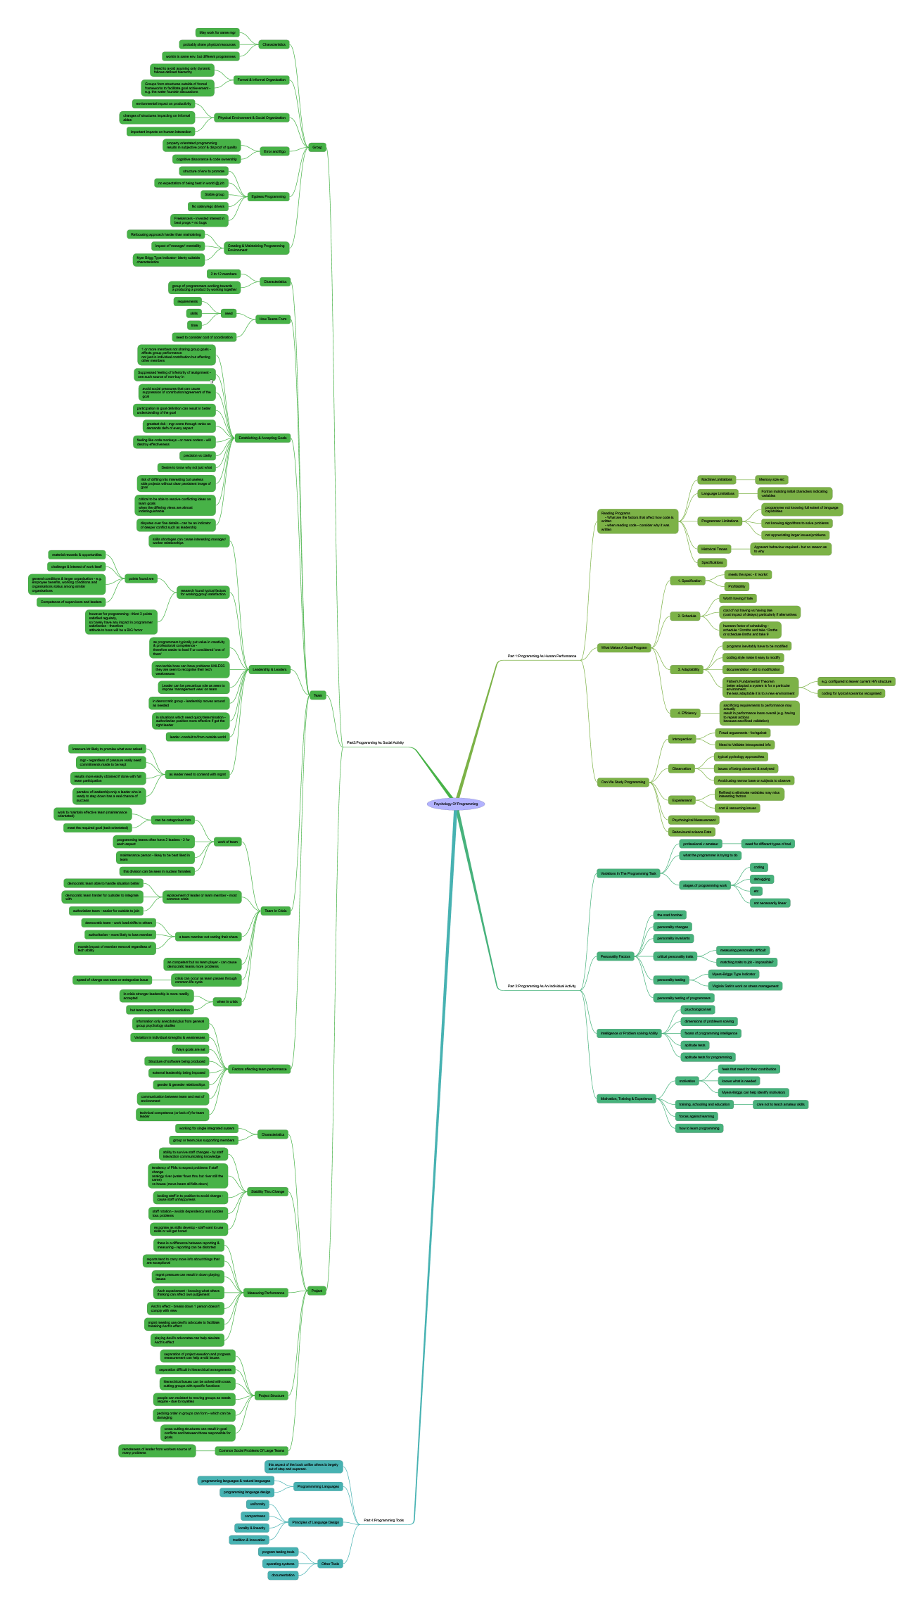

Psychology Of Programming

- Part 1:Programming As Human Performance
  - Reading Programs
What are the factors that affect how code is written
when reading code - consider why it was written
    - Machine Limitations
      - Memory size etc
    - Language Limitations
      - Fortran insisting initial characters indicating variables
    - Programmer Limitations
      - programmer not knowing full extent of language capabilities
      - not knowing algorithms to solve problems
      - not appreciating larger issues/problems
    - Historical Traces
      - Apparent behaviour required - but no reason as to why
    - Specifications
  - What Makes A Good Program
    - Specification
      - meets the spec - it 'works'
      - Profitability
    - Schedule
      - Worth having if late
      - cost of not having vs having late
(cost impact of delays) particularly if alternatives
      - humean factor of scheduling -
schedule 12cmths and take 12mths
or schedule 6mths and take 9
    - Adaptability
      - programs inevitably have to be modified
      - coding style make it easy to modify
      - documentation - aid to modification
      - Fisher's Fundamental Theorem
better adaptad a system is for a particular environment,
the less adaptable it is to a new environment
        - e.g. configured to leaver current HW structure
        - coding for typical scenarios recognised
    - Efficiency
      - sacrificing requirements to performance may actually
result in performance losss overall (e.g. having to repeat actions
because sacrificed validation)
  - Can We Study Programming
    - Introspection
      - Fraud arguements - for/against
      - Need to Validate introspected info
    - Observation
      - typical pychology approacthes
      - issues of being observed & analysed
      - Avoid using narrow base or subjects to observe
    - Experiement
      - Refined to eliminate variables may miss interesting factors
      - cost & resourcing issues
    - Psychological Measurement
    - Behavioural science Data
- Part 3:Programming As An Individual Activity
  - Variations In The Programming Task
    - professional v amateur
      - need for different types of tool
    - what the programmer is trying to do
    - stages of programming work
      - coding
      - debugging
      - etc
      - not necessarily linear
  - Personality Factors
    - the mad bomber
    - personality changes
    - personality invariants
    - critical personality traits
      - measuring personality difficult
      - matching traits to job - impossible?
    - personality testing
      - Myers-Briggs Type Indicator
      - Virginia Satir's work on stress management
    - personality testing of programmers
  - Intelligence or Problem solving Ability
    - psychological set
    - dimensions of problewm solving
    - facets of programming intelligence
    - aptitude tests
    - aptitude tests for programming
  - Motivation, Training & Experience
    - motivation
      - feels that need for their contribution
      - knows what is needed
      - Myers-Briggs can help identify motivators
    - training, schooling and education
      - care not to teach amateur skills
    - forces against learning
    - how to learn programming
- Part 4:Programming Tools
  - this aspect of the book unlike others is largely out of step and superset.
  - Programmming Languages
    - programming languages & natural languages
    - programming language design
  - Principles of Language Design
    - uniformity
    - compactness
    - locality & linearity
    - tradition & innovation
  - Other Tools
    - program testing tools
    - operating systems
    - documentation
- Part2:Programming As Social Activity
  - Group
    - Characteristics
      - May work for same mgr
      - probably share physical resources
      - workin is same env. but different programmes
    - Formal & Informal Organisation
      - Need to avoid asuming only dynamic
follows defined hierarchy
      - Groups form structures outside of formal
frameworks to facilitate goal achievement -
e.g. the water fountain discussions
    - Physical Environment & Social Organization
      - envionmental impact on productivity
      - changes of structures impacting on informal aides
      - important impacts on human interaction
    - Error and Ego
      - property orientated programming
results in subjective proof & disproof of quality
      - cognitive dissonance & code ownership
    - Egoless Programming
      - structure of env to promote
      - no expectation of being best in world @ job
      - Stable group
      - No salary/ego drivers
      - Freelancers - invested interest in
best progs = no bugs
    - Creating & Maintaining Programming Environment
      - Refocusing approach harder than maintaining
      - impact of 'manager' mentaility
      - Nyer Brigg Type Indicator- identy suitable characteristics
  - Team
    - Characteristics
      - 2 to 12 members
      - group of programmers working towards
a producing a product by working together
    - How Teams Form
      - need
        - requirements
        - skills
        - time
      - need to consider cost of coordination
    - Establishing & Accepting Goals
      - 1 or more members not sharing group goals - affects group performance
not just in individual contribution but affecting other members
      - Suppressed feeling of inferiority of assignment - one such source of non-buy in
This can manifest itself in various ways such as developers by passing or subverting processes and deisgn guidelines to implement things the way they think is correct
      - avoid social pressures that can cause
suppression of contribution/agreement of the goal
      - participation in goal definition can result in better understanding of the goal
      - greatest risk - mgr come through ranks an demands defn of every aspect
      - feeling like code monkeys - or mere coders - will destroy effectiveness
      - precision vs clarity
      - Desire to know why not just what
      - risk of drifting into interesting but useless
side projects without clear persistent image of goal
      - critical to be able to resolve conflicting ideas on team goals
when the differing views are almost indistinguishable
      - disputes over fine details - can be an indicator of deeper conflict such as leadership
    - Leadership & Leaders
      - skills shortages can create interesting manager/worker relationships
      - research found typical factors
for working group satisfaction
        - points found are
          - material rewards & opportunities
          - challenge & interest of work itself
          - general conditions & larger organisation - e.g.
employee benefits, working conditions and
organisations status among similar organisations
          - Competence of supervisors and leaders
        - however for programming - thirst 3 points satisfied regularly,
so barely have any impact in programmer satisfaction - therefore
attitude to boss will be a BIG factor
      - as programmers typically put value in creativity & professional competence -
therefore easier to lead if ur considered 'one of them'
      - non techie boss can have problems UNLESS they are seen to recognise their tech weaknesses
      - Leader can be precarious role as seen to impose 'management view' on team
      - in democratic group - leadership moves around as needed
      - in situations which need quick/determination -
authoritarian position more effective if got the right leader
      - leader -conduit to/from outside world
      - as leader need to contend with mgmt
        - insecure ldr likely to promise what ever asked
        - mgr - regardless of pressure really need commitments made to be kept
        - results more easily obtained if done with full team participation
        - paradox of leadership:only a leader who is ready to step down has a real chance of success
    - Team In Crisis
      - work of team
        - can be catagorised into
          - work to maintain effective team (maintenance orientated)
          - meet the required goal (task-orientated)
        - programming teams often have 2 leaders - 2 for each aspect
        - maintenance person - likely to be best liked in team
        - this division can be seen in nuclear famalies
      - replacement of leader or team member - most common crisis
        - democratic team able to handle situation better
        - democratic team harder for outsider to integrate with
        - authoriatian team - easier for outside to join
      - a team member not carting their share
        - democratic team - work load shifts to others
        - authoritarian - more likely to lose member
        - morale impact of member removal regardless of tech ability
      - an competent but no team player - can cause democratic teams more problems
      - crisis can occur as team passes through common life cycle
        - speed of change can ease or antagonise issue
      - when in crisis
        - in crisis stronger leadership is more readily accepted
        - but team expects more rapid resolution
    - Factors affecting team performance
      - information only anecdotal plus from general group psychology studies
      - Variation in individual strengths & weaknesses
      - Ways goals are set
      - Structure of software being produced
      - external leadership being imposed
      - gender & geneder relationships
      - communication between team and rest of environment
      - technical competence (or lack of) for team leader
  - Project
    - Characteristics
      - working for single integrated system
      - group or team plus supporting members
    - Stability Thru Change
      - ability to survive staff changes - by staff interaction communicating knowledge
      - tendency of PMs to expect problems if staff change
analogy river (water flows thru but river still the same)
vs house (move beam all falls down)
      - locking staff in to position to avoid change - cause staff unhappyness
      - staff rotation - avoids dependency and sudden loss problems
      - recognise as skills develop - staff want to use skills or will get bored
    - Measuring Performance
      - there is a difference between reporting & measuring - reporting can be distorted
      - reports tend to carry more info about things that are exceptional
      - mgmt pressure can result in down playing issues
      - Asch experiement - knowing what others thinking can affect own judgement
      - Asch's effect - breaks down 1 person doesn't comply with view
      - mgmt meeting use devil's advocate to facilitate breaking Asch's effect
      - playing devil's advocatae can help aleviate Asch's effect
    - Project Structure
      - separation of project exeution and progress measurement can help avoid issues
      - separation difficult in hierarchical arrangements
      - hierarchical issues can be solved with cross cutting groups with specific functions
      - people can resistant to moving groups as needs require - due to loyalties
      - pecking order in groups can form - which can be damaging
      - cross cutting structures can result in goal conflicts and between those responsible for goals
    - Common Social Problems Of Large Teams
      - remoteness of leader from workers source of many problems

