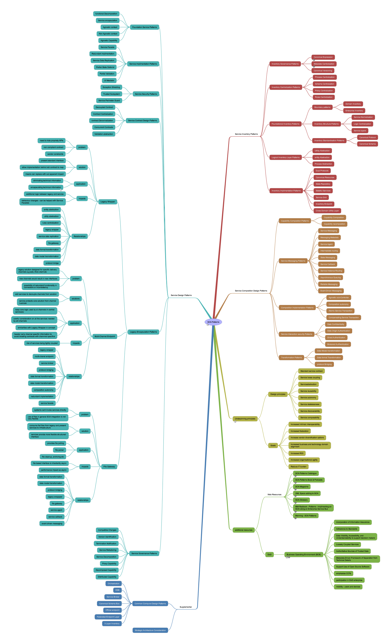

SOA Patterns
Built front SOA Design Patterns by Thomas Erl - Prentice Hall - http://www.soapatterns.org/
- Service Inventory Patterns
  - Inventory Governance Patterns
    - Canonical Expression
http://www.soapatterns.org/canonical_expression.asp
    - Metadata Centralization
http://www.soapatterns.org/metadata_centralization.asp
    - Canonical Versioning
  - Inventory Centralization Patterns
    - Process Centralization
    - Schema Centraization
    - Policy Centralization
    - Rules Centralization
  - Foundational Inventory Patterns
    - Boundary patterns
      - Domain Inventory
      - Enterprise Inventory
    - Inventory Structure Patterns
      - Service Normalization
      - Logic Centralization
      - Service layers
    - Inventory Standardisation Patterns
      - Canonical Protocol
      - Canonical Schema
  - Logical Inventory Layer Patterns
    - Utility Abstraction
    - entity Abstraction
    - Process Abstraction
  - Inventory Implimentation Patterns
    - Dual Protocols
    - Canonical Resources
    - State Repository
    - Stateful Services
    - Service Grid
    - Inventory Endpoint
    - Cross Domain Utility Layer
- Service Composition Design Patterns
  - Capability Composition Patterns
    - Capability Composition
    - Capability recomposition
  - Service Messaging Patterns
    - Service Messaging
    - Messaging Metadata
    - Service Agent
    - Intermediate routing
    - State Messaging
    - Service Callback
    - Service Instance Routing
    - Asynchronous Queuing
    - Reliable Messaging
    - Event Driven Messaging
  - Composition Implementation Patterns
    - Agnostic sub-Controller
    - Composition autonomy
    - Atomic Service Transaction
    - Compensating Service Transaction
  - Service Interaction security Patterns
    - Data Confidentiality
    - Data Origin Authentication
    - Direct Authentication
    - Brokered Aurthentication
  - Transformation Patterns
    - Data Model transformation
    - Data format Transformation
    - protocol Bridging
- Underpinning principles
Drawn from chapter 4
  - Design principles
    - Standard service contract
    - Service loose coupling
    - Serviceabstraction
    - Service reusability
    - Service autonomy
    - Service statelessness
    - Service discoverability
    - Service composability
  - Goals
    - Increased intrinsic interoperability
    - Increased federation
    - Increase vendor diversification options
    - Increased business and technology domain alignment
    - Increased ROI
    - Increased organisational agility
    - Reduce IT burden
- additional resources
  - Web Resources
    - SOA Patterns Catalogue
http://www.soapatterns.org/
    - SOA Patterns Book & Podcasts
http://www.soapatterns.com/
    - SOA Magazine
http://www.soamag.com/default.asp
    - XML Specs adding to SOA
http://www.soaspecs.com/
    - SOA Glossary
http://www.soaglossary.com/
    - IBM Redbook - Patterns - Implimenting an
SOA Using an Enterprise Service Bus
http://docs.huihoo.com/soa/ibm/sg246346.pdf
    - Manning - SOA Patterns
http://www.soapatternsbook.com/
  - DoD
    - Business Operating Environment (BOE)
set of principles to correlate Service orientated design with SOA patterns. This in effect is a SOA compound pattern
Emphasis on incremental adoption of SOA
BEA - Business Enterprise Arcitecture
BMA - Business Mission Area
http://SOADoD.org
      - incorporation of Information Assurance
      - Adherence to Standards
      - Data Visibility, Accessibility, and Understandability to support decision makers
      - Loosely Coupled Services
      - Authoritative Sources of Trusted Data
      - Metadata-Driven Framework of Separation from Technical Details
      - Support Use of Open Source Software
      - emphasise COTs
      - participation in DoD enterprise
      - mobility - users and devices
- Supplemental
  - Common Compund Design Patterns
    - Orchestration
    - ESB
    - Service Broker
    - Canonical Schema Bus
    - Official endpoint
    - Federated Endpoint Layer
    - 3 Layer Inventory
  - Strategic Architecture Consideration
- Service Design Patterns
  - Foundation Service Patterns
    - functional Decomposition
    - Service encapsulation
    - Agnostic context
    - Non Agnostic context
    - Agnostic Capability
  - Service Implimentation Patterns
    - Service Facade
    - Redundant implimentation
    - Service Data Replication
    - Partial State Deferral
    - Partial Validation
    - UI Mediator
  - Service Security Patterns
    - Exception Shielding
    - Trusted Subsystem
    - Service Perimeter Guard
  - Service Contract Design Patterns
    - Decoupled Contract
    - Contract Centralization
    - contract Denormalization
    - Concurrent Contracts
    - Validation abstraction
  - Legacy Encapsulation Patterns
    - Legacy Wrapper
      - problem
        - need to hide propriety APIs
        - non compliant contract
        - vendor constraints
      - solution
        - present standard interface
        - allow implementation behind std contract to map
        - means can replace with out apparent impact
      - application
        - eliminating technical information
        - encapsulating technical information
things like how errors are reported need to be encapsulated e.g. SOAP error mechanism vs error messages
      - impacts
        - additional logic between legacy and service
        - behaviour changes - can be helped with Service Facades
      - Relationships
        - entity abstraction
        - utility abstraction
        - rules centralization
        - legacy wrapper
        - service data replication
        - file gateway
        - data format transformation
        - data model trannsformation
        - protocol bridge
    - Multi-Channel Endpoint
      - problem
        - legacy solution designed for specific delivery channels e.g web, thick client etc
        - new channels would result in new interfaces
        - possibility of redundant functionality in connectors or inconsistency
      - solutions
        - add services to decouple channels from solution
        - service protects core solution from channel nuances
      - application
        - keep core logic used by al channels in central service(s)
        - careful consideration on all the services needed by alll channels
        - similarities with Legacy Wrapper in concept
        - header carry channel specific information to avoid bloating contracts with channnel specifics
      - impacts
        - risk of services being tightly coupled
      - relationships
        - legacy wrapper
        - multi-chanel endpoint
        - service broker
        - protocol bridging
        - data format transformation
        - data model transformatiion
        - composition autonomy
        - redundant implementation
        - service facade
    - File Gateway
      - problem
        - systems cant invoke services directly
        - use of files in general SOA integration is not very flexible
      - solution
        - consume flat files from legacy and present services to infrastructure
        - services provide more flexible structured interface
      - application
        - provides fiie polling
        - file parser
        - file cleanup, archiving etc
      - impacts
        - file based interface is inhertantly async
        - performance impact as async
      - relationships
        - data format transformation
        - data model transformation
        - protocol bridging
        - legacy wrappper
        - file gateway
        - service agent
        - service callback
        - event driven messaging
  - Service Governance Patterns
    - Compatible Changes
    - Version Identification
    - Termination Notification
    - Service Refactoring
    - Service Decomposition
    - Proxy Capability
    - Decomposed Capability
    - Distributed Capability

