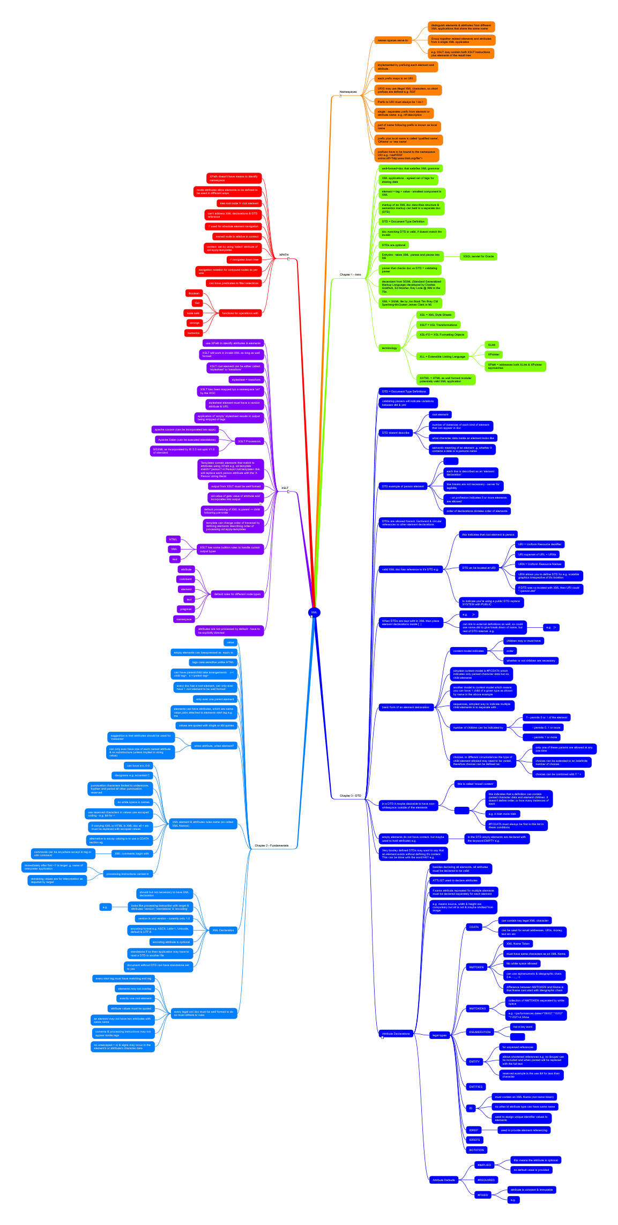

XML
XML In A Nutshell - A Desktop Quick Reference, 1st Edition
http://www.oreilly.com/catalog/xmlnut/
- Namespaces
Chapter 4, p58
  - names spaces serve to:
    - distinguish elements & attributes from different XML applications that share the same name
    - Group together related elements and attributes from a single XML application
    - e.g. XSLT may contain both XSLT instructions plus elements of the result tree
  - implemented by prefixing each element and attribute.
  - each prefix maps to an URI
  - URIS may use illegal XML characters, so short prefixes are defined e.g. RDF
  - Prefix to URI must always be 1-to-1
  - single : separates prefix from element or attribute name e.g. rdf:description
  - part of name following prefix is known as local name
  - prefix plus local name is called 'qualified name', 'QName' or 'raw name'
  - prefixes have to be bound to the namespace URI e.g. <redf:RDF xmlns:rdf="http:www.blah,org/file">
- Chapter 1 - Intro
  - well-formed=doc that satisfies XML grammar
  - XML applications - agreed set of tags for sharing data
  - element = tag + value - smallest component in XML
  - markup of an XML doc describes structure & semantics markup can held in a separate doc (DTD)
  - DTD = Document Type Definition
  - doc matching DTD is valid, if doesnt match thn invalid
  - DTDs are optional
  - Enhydra - takes XML parses and places into DB
    - XSQL servlet for Oracle
  - parser that checks doc vs DTD = validating parser
  - decendant from SGML (Standard Generalized Markup Language) developed by Charles Goldfarb, Ed Mosher, Ray Lorie @ IBM in the 70s
  - XML = SGML lite by Jon Bosk Tim Bray CM Sperberg-McQueen James Clark in 96
  - terminology
    - XSL = XML Style Sheets
    - XSLT = XSL Transformations
    - XSL-FO = XSL Formatting Objects
    - XLL = Extensible Linking Language
      - XLink
      - XPointer
      - XPath = addresses both XLink & XPointer approaches
    - XHTML = HTML as well formed modular potentially valid XML application
- Chapter 3 - DTD
  - DTD = Document Type Definitions
  - validating parsers will indicate variations between dtd & xml
  - DTD doesnt describe
    - root element
    - number of instances of each kind of element that can appear in doc
    - what character data inside an element looks like
    - semantic meaning of an element .g. whether it contains a date or a persons name
  - DTD example of person element

    - each line is described as an 'element declaration'
    - line breaks are not necessary - server for legibility
    - on profresion indicates 0 or more elements are allowed
    - order of declarations dictates order of elements
  - DTDs are allowed foward, backward & circular references to other element declarations
  - valid XML doc has reference to it's DTD e.g.
    - this indicates that root element is person
    - DTD an be located at URI
      - URI = Uniform Resource dentifier
      - URI superset of URL + URNs
      - URN = Uniform Resource Names
      - URN allows you to define DTD for e.g. scalable graphics irrespective of it's location
      - if DTD was co located with XML then URI could "./person.dtd"
    - to indicate you're using a public DTD replace SYSTEM with PUBLIC
  - When DTDs are kept with in XML then place element declarations inside [ ]
    - e.g. ]>
    - can link in external definitions as well, so could use name.dtd to give break down of name, but rest of DTD internal. e.g.
      - e.g. ]>
  - basic form of an element delcaration:
    - content model indicates
      - children may or must have
      - order
      - whether or not children are necessary
    - simplest content model is #PCDATA which indicates only parsed character data but no child elements
    - another model is content model which means you can have 1 child of a given type as shown by name in the above example
    - sequences, simplest way to indicate multiple child elements is to separate with ,
    - number of children can be indicated by
      - ? - permits 0 or 1 of the element
      - permits 0, 1 or more
      - permits 1 or more
    - choices, in different circumstances the type of child element allowed may need to be varied, therefore choices can be defined as:
      - only one of these params are allowed at any one time
      - choices can be extended to an indefinite number of choices
      - choices can be combined with ? * +
  - in a DTD it maybe desirable to have non-whitespace outside of the elements
    - this is called 'mixed content'

      - this indicates that a definition can contain parsed character data and element children. It doesn't define order, or how many instances of each
      - e.g. A blah more blah
      - #PCDATA must always be first in this list in these conditions
  - empty elements do not have content, but maybe used to hold attributes e.g.
    - in the DTD empty elements are declared with the keyword EMPTY e.g.
  - Very loosley defined DTDs may want to say that an element exists without defining it's content. This can be done with the word ANY e.g.
  - Attribute Declarations
Page 39
    - besides declaring all elements, all atributes must be declared to be valid
    - ATTLIST used to declare attributes
    - if same attribute repreated for multiple elements must be declared separately for each element
    - e.g means source, width & height are compulsary but alt is not & maybe omitted from image
    - legal types
      - CDATA
        - can contain nay legal XML character
        - can be used for email addresses, URIs, money, text etc etc
      - NMTOKEN
        - XML Name Token
        - must have same characters as an XML Name
        - No white space allowed
        - can use alphanumeric & ideographic chars (i.e. . , _ -)
        - difference between NMTOKEN and Name is that Name cant start with ideographic chars
      - NMTOKENS
        - collection of NMTOKEN separated by white space
        - e.g. <performances dates="09/02" "10/02" "11/02">A Show
      - ENUMERATION
        - not a key word

      - ENTITY
        - for unparsed references
        - allows shortened references e.g no &super can be included and when parsed will be replaced with the full text
        - reserved example is the use &lt for less than character
      - ENTITIES
      - ID
        - must contain an XML Name (not name token)
        - no other id attribute type can have same name
        - used to assign unique identifier values to elements
      - IDREF
        - used to provide element referencing
      - IDREFS
      - NOTATION
    - Attribute Defaults
      - #IMPLIED
        - this means the attribute is optional
        - no default value is provided
      - #REQUIRED
      - #FIXED
        - attribute is constant & immutable
        - e.g.
- Chapter 2 - Fundamentals
  - value
  - empty elements can beexpressed as equiv to
  - tags case sensitive unlike HTML
  - can have parent/child take arrangements c</child tag> s </parent tag>
  - every doc has a root element, can only ever have 1 root element to be well formed
  - only ever one parent element
  - elements can have attributes, which are name value pairs attached to elements start tag e.g. me
  - values are quoted with single or dbl quotes
  - when attribute, when element?
    - suggestion is that attributes should be used for 'metadata'
    - can only ever have one of each named attribute & no substructure (unless implied in string value)
  - XML element & attributes rules same (so called XML Names)
    - can have a-z, 0-9
    - ideograms e.g. accented C
    - punctuation characters limited to underscore, hyphen and period all other punctuation reserved
    - no white space in names
    - use reserved characters in values use escaped coding - e.g. &lt for <
    - if carrying XML or HTML in XML doc all < etc must be replaced with escaped values
    - alternative to escap valuing is to use a CDATA section eg html in italics]]>
    - XML comments begin with
      - comments can be anywhere except in tag or othr comment
    - processing instructions carried in
      - immediately after first <? is target .g. name of interpreter application
      - remaining values are for interpreation as required by target
  - XML Declaration
    - should but not necessary to have XML declaration
    - looks like processing instruction with target & attributes 'version', 'standalone' & 'encoding'
      - e.g.
    - version is xml version - curently only 1.0
    - encoding format e.g. ASCII, Latin-1, Unicode, default is UTF-8
    - encoding attribute is optional
    - standalone if no then application may have to read a DTD in another file
    - document without DTD can have standalone set to yes
  - every legal xml doc must be well formed to do so must adhere to rules
    - every start tag must have matching end tag
    - elements may not overlap
    - exactly one root element
    - attribute values must be quoted
    - an element may not have two attributes with same name
    - coments & processing instructions may not appear inside tags
    - no unescaped < or & signs may occur in the element's or attribute's character data
- XSLT
P129
aka XSL Transforms or XSL Templates
  - use XPath to identify attributes & elements
  - XSLT will work in invalid XML as long as well formed
  - XSLT root element can be either called 'stylesheet' or 'transform'
  - stylesheet = transform
  - XSLT has been mapped tyo a namespace 'xsl' by the W3C
  - stylesheet element must have a version attribute & URL
  - application of 'empty' stylesheet results in output being stripped of tags
  - XSLT Processors
    - apache cocoon (can be incorporated into apps)
    - Apache Xalan (can be executed standalone)
    - MSXML as incorporated by IE 5.5 not upto V1.0 of standard
  - Templates contain elements that match to attributes using XPath e.g. xsl:template match="person">A Person</xsl:template> this will replace each person attribute with the 'A Person' string literal
  - output from XSLT must be well formed
  - xsl:value-of gets value of attribute and incorpoates into output
example on p135
  - default processing of XML is parent -> child following pre-order
  - template can change order of traversal by defining elements describing order of processing xsl:apply-templates
  - XSLT has some builtinn rules to handle curtain output types
    - HTML
    - XML
    - text
  - default rules for different node types
    - attribute
    - comment
    - element
    - text
    - pragmas
    - namespace
  - attributes are not processed by default - have to be explicitly directed
- XPATH
p147
  - XPath doesn't have means to identify namespace
  - mode attributes allow elements to be defined to be used in different ways
  - tree root node != root element
  - can't address XML declarations & DTD reference
  - '/' used for absolute element navigation
  - named node is relative to context
  - context set by using 'select' attribute of xsl:apply-templates
  - // navigates down tree
  - navigation notation for compund nodes as per unix
  - can have predicates to filter selections
  - functions for operations with
    - Boolean
    - Set
    - node sets
    - strongs
    - numerics

